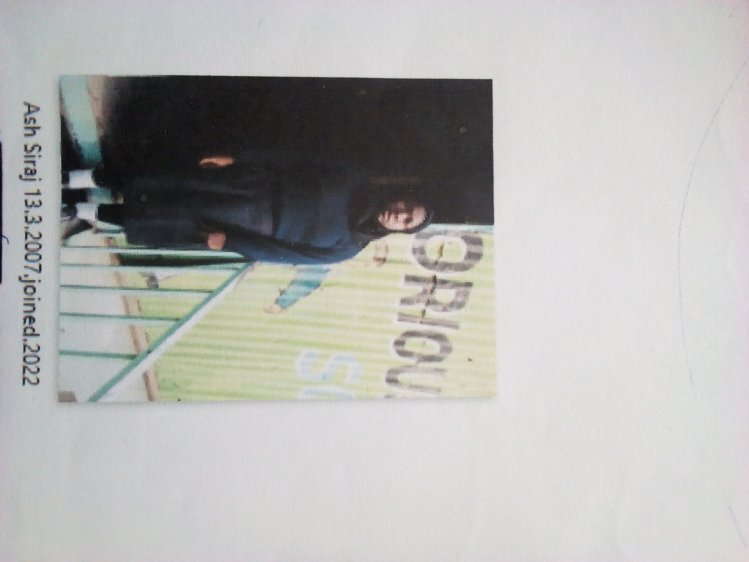

ASHA SIRAJ FORM 1 BORN 2007 JOINED 2021
Asha 14 years was enrolled in our school when he was 14 years old. Asha is a need girl with a cute affinity to grasp contents very fast. Asha cannot locate her parents they were picked by unknown people. For the last 3 years they are nowhere to be found. She has faced tough times in the past living like a nomad. She sought help from Glorious. After establishing the truth about her situation we resolved to allow him access education.
Thanks to the Director Mr. Boniface Mangeti who allowed Asha in school. I am now learning in glorious at least I have a place I call home praying that one day God will help our school have good classes, toilets and enough study materials. Thank you Mitchell and Brad for your support have really helped many in Mukuru

